Urgent ____________

County____________

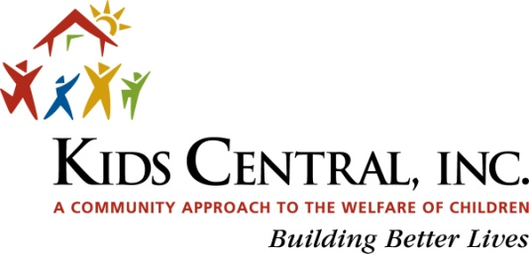 Kinship Care Referral Form
For Office Use Only: FSFN History: ____ Yes ____No Dependency: ____No ____Closed ____Open Open Abuse Report: _____Yes ____ No

Dependency Case Worker:____________ DCF Investigator____________________

DATE OF REFERRAL: CASE NAME:
GENERAL INFORMATION ABOUT RELATIVE CAREGIVER BEING REFERRED
1) Caregiver #1: Date of Birth: Social Security #:
Caregiver #2: Date of Birth: Social Security #:
2) Address: City, State, ZIP
Email Address
3) Telephone Numbers: Home Work Cell
4) Total Number of Relative Children in the Home:
5) Caregivers Relationship(s) to the Children:
6) Parent’s Name, DOB and Current Location:

7) Are siblings placed all together?______________ If not, where are the other siblings? _______________________________

CHILD’S FULL NAME | BIRTH DATE | SOCIAL SECURITY # | CURRENT LEGAL STATUS
A.
B.
C.
D.

KINSHIP CARE SERVICES NEEDED/DESIRED (please check all that apply): Daycare, Access Florida and Legal Assistance are only available for non-dependency cases.

___SUPPORT GROUP ____RESOURCE DIRECTION ___DAYCARE ___ACCESS FL ____LEGAL ASSISTANCE ___OTHER:

COMMENTS / NOTES

_________________________________________________________________________________________________________________________

_________________________________________________________________________________________________________________________

_________________________________________________________________________________________________________________________

_________________________________________________________________________________________________________________________

_________________________________________________________________________________________________________________________

NAME OF PERSON COMPLETING FORM: AGENCY:

PHONE NUMBER: EMAIL:

Referral can be faxed to 352-387-3558, or sent via email to Michelle.Mongeluzzo@kidscentralinc.org
If you have any questions please contact the Kinship Navigator at 352-387-3526

Revised 01/2013

Pursuant to Section 286.26, Florida Statutes, any disabled person who may require accommodations to participate in any meetings or events, please contact Debra Wise or Shelly LaFrance with Kids Central at (352) 873-6332 at least 7 days in advance of the event. If you are hearing or speech impaired, please use the Florida Relay Service 1-800-955-8771 (TDD) or 1-800-955-8770 (Voice).

